10.1.11 Editors - Geometry Nodes Editor - Header - Add Menu - Point
Detailed table of content 1
Add menu - Point 2
Point Distribute 2
Point Instance 3
Point Separate 3
Rotate Points 4

Detailed table of content
Detailed table of content
Detailed table of content 1
Add menu - Point 2
Point Distribute 2
Inputs 2
Geometry 2
Distance Min 2
Density Max 2
Density Attribute 2
Properties 2
Distribution Method 2
Random 2
Poisson Disk 3
Seed 3
Output 3
Geometry 3
Point Instance 3
Inputs 3
Geometry 3
Object / Collection 3
Properties 3
Instance Type 3
Outputs 3
Geometry 3
Point Separate 3
Inputs 4
Mask 4
Outputs 4
Geometry 1 4
Geometry 2 4
Rotate Points 4
Inputs 4
Geometry 4
Rotation 4
Properties 4
Rotate Type 4
Axis Angle 4
Euler 4
Rotate Space 4
Object 4
Point 4
Input Type Rotation 5
Outputs 5
Geometry 5

Add menu - Point
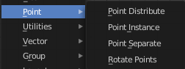
Point related nodes.

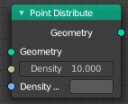
Point Distribute
The Point Distribute node distributes points on the surface of the input geometry object.

Inputs

Geometry
Standard geometry input. Note that only meshes are supported.

Distance Min
The minimal distance points can have to each other. Note that this option is only available on distribution methods that supports it.

Density Max
The point density for the point distribution. In other words, how many points there will be within one square meter. Note that this will be capped on distributions with the Distance Min option. If the density is greater than what the minimal distance allows, no new points will be added after this threshold has been passed.

Density Attribute
Which attribute to use for influencing the point density. The input values are mapped between zero and the Density.

Properties
This properties most probably just shows under some circumstances, which we haven't managed to reproduce yet. The Blender manual does not give any hint here.

Distribution Method

Random
Distribute points randomly on the surface.

Poisson Disk
Project points on the surface evenly with a Poisson disk distribution.

Seed
The random seed to use when generating points.

Output

Geometry
Generated points.

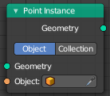
Point Instance
The Point Instance node instances an element to each of the points present in the input geometry. It works for both point cloud and mesh vertices.
Note that this node only works if the modifier belongs to a point cloud object.

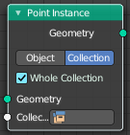
Inputs

Geometry
Standard geometry input.

Object / Collection
The object or collection to instantiate.

Properties

Instance Type
Instance an object or a collection. The input type changes dependant of the choice here.

Outputs

Geometry
Standard geometry output.

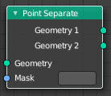
Point Separate
Produces two output geometries. The point cloud component of the input geometry is split between the two outputs, based on the threshold and the input attribute
Tip! To get a more precise result you can combine the node with the Attribute Compare node.

Inputs

Mask
The name of the attribute used to calculate which geometry output each point will belong to. Any value of “true” will move to the second output, and any value of “false” will move the point to the first output.
If the attribute has any data type besides boolean, the value will be implicitly converted, so a value of exactly zero is false, and any other value is true.

Outputs

Geometry 1
Points with a mask attribute value of “true” will be moved to the first input.

Geometry 2
Points with a mask attribute value of “false” will be moved to the first input.

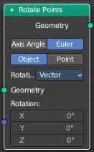
Rotate Points
Rotates points.

Inputs

Geometry
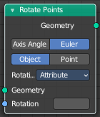
Use the rotation of an existing geometry.

Rotation
The input rotation. Baset at a vector, or based at an attribute.

Properties

Rotate Type

Axis Angle
Rotate around an axis by an angle.

Euler
Rotate around the x, y and z axis.

Rotate Space

Object
Rotate points in the local space of the object.

Point
Rotate every point in its local space.

Input Type Rotation
If the rotation is based at an attribute or at an vector.

Outputs

Geometry
Standard geometry output.

